Risk Management Report Requirements

1**Document Properties**

|  |  |
| --- | --- |
| Status: | **Approved** |
| Version: | **1** |
| Author: | Laurence Sampson |
| Created: | 2015-08-21 14:29 |

**Approved Versions**

Current document version**1** is **approved.**Approved Versions:

* [**1**](http://tamans-ap525v:80/polarion/#/project/SabreProduction/wiki/polarion/Risk%20Management%20Report%20Requirements?revision=2450) (2015-09-28 17:48 )

**Document Signatures**

|  |  |  |  |
| --- | --- | --- | --- |
| **Reviewed** (2015-09-28 17:47) | | | |
|  | **Laurence Sampson** | Signed | 2015-09-28 17:46 |
| **Approved** (2015-09-28 17:48) | | | |
|  | **Laurence Sampson** | Signed | 2015-09-28 17:47 |

*Please update the table of contents.*

​​

​​

​​

​​

​​

​​

# Background

This document is to describe the method used to characterize risk in a medical device development project.   It is intended to provide direction in the development of a custom report.

# Macro Scope

The macro scope is a project in the Polarion requirements management system.

Current revision of Polarion:  3.9.1

# Referenced Standards

## International Standards

ISO 13485

ISO 14971:2003

ISO 14971:2012

# Covidien SOP

# Test Instance

Medical device template on the Partnerps server

# Design Inputs

## User Needs

SabreProduction/D7371-6579Compliance with 14971

SabreProduction/D7371-6580Compliance with Covidien RAC template

## Current Reports

**xFMEA Risk Analysis** - The current report shows the harms/hazardous situation progression, but there is no riskRecord associated with a harm/hazardous situation combination.  This means that the data associated with the combination of the two does not exist in the work items as defined.  The report is contained in the "Reports" space.

## Current Macros

**riskMacros** - Support the current xFMEA Risk Analysis report.  The macro is contained in the "macros" space.

## Requirements

### Report Format

SabreProduction/D7371-6572**D7371-6572 -**The risk report will show/indicate data in the following format columns:  
**[**Open**]**

​​

#### Column Sources

SabreProduction/D7371-6617**D7371-6617 -**The Polarion Risk Record column will be populated with the Risk Record Polarion ID**[**Open**]**

SabreProduction/D7371-6618**D7371-6618 -**The Hazard will be a text field as defined in the Hazardous Situation work item (D7371-6147).**[**Open**]**

SabreProduction/D7371-6619**D7371-6619 -**The Hazard ID ??**[**Open**]**

SabreProduction/D7371-6620**D7371-6620 -**The Hazardous Situation column will be the HS Polarion ID and description**[**Open**]**

SabreProduction/D7371-6621**D7371-6621 -**The Essential Performance column will be the field located in the Risk Record work item (D7371-6145).**[**Open**]**

SabreProduction/D7371-6622**D7371-6622 -**The Harm column will be populated with the Harm work item Polarion ID and description.**[**Open**]**

SabreProduction/D7371-6623**D7371-6623 -**The Source column will be populated with any uplinked sources work item ID and descriptions (Statutory Source, Product Source)**[**Open**]**

SabreProduction/D7371-6624**D7371-6624 -**The FMEA line column will be populated with a text field as defined in  the Risk Record work item (D7341-6145).**[**Open**]**

SabreProduction/D7371-6625**D7371-6625 -**The Possible Cause column will be populated with a text field as defined in the Harm work item (D7341-6144).**[**Open**]**

SabreProduction/D7371-6626**D7371-6626 -**The Harm severity (which is the same for both pre and post mitigation values) will be an enumeration field as defined in the Harm work item (D7341-6144).**[**Open**]**

SabreProduction/D7371-6627**D7371-6627 -**The Pre-mitigation P1 occurrence column enumeration will be defined in the Hazardous Situation work item (D7371-6143).**[**Open**]**

SabreProduction/D7371-6628**D7371-6628 -**The risk index (RPL, or RI) enumeration defined in a table in (D7341-5766) will be located in the Risk Record work item (D7341-6145).**[**Open**]**

SabreProduction/D7371-6629**D7371-6629 -**The Occurrence Rational column will be the Occurrence Rational rich text field defined in the Hazardous Situation work item (D7371-6143).**[**Open**]**

SabreProduction/D7371-6630**D7371-6630 -**The Risk/Control column will be deteted**[**Open**]**

SabreProduction/D7371-6631**D7371-6631 -**The Risk Mitigation will be populated with the Polarion ID and Description for every Requirement, User Need and Manufacturing Requirement linked to the Hazardous Situation.**[**Open**]**

SabreProduction/D7371-6632**D7371-6632 -**The Verification of Implementation column is an enumeration field in the Hazardous Situation work item (D7371-6143).**[**Open**]**

SabreProduction/D7371-6633**D7371-6633 -**The Verification of Effectiveness column is an enumeration field in the Hazardous Situation work item (D7371-6143).**[**Open**]**

SabreProduction/D7371-6634**D7371-6634 -**The Post-mitigation P1  columnis an enumeration field in the Hazardous Situation work item (D7371-6143).**[**Open**]**

SabreProduction/D7371-6635**D7371-6635 -**The Post-mitigation Harm Severity column is the same variable from the Harm work item used for the pre-mitigation value above (D7341-6144).**[**Open**]**

SabreProduction/D7371-6636**D7371-6636 -**The Post-mitigation PRL/RI  column will be located in the Risk Record work item (D7341-6145).**[**Open**]**

SabreProduction/D7371-6637**D7371-6637 -**The Is Risk Acceptable?  column will be located in the Risk Record work item (D7341-6145).**[**Open**]**

SabreProduction/D7371-6638**D7371-6638 -**The Risk Acceptance Rationale column will be located in the Risk Record work item (D7341-6145).**[**Open**]**

​​

### Report Progression

SabreProduction/D7371-6574**D7371-6574 -**The report will be generated in the following order:

1. Harm
2. Hazardous Situation
3. Mitigations

Harms will be listed in order with the riskRecord shown to the left as depicted in the column format in D7371-6572**[**Open**]**

SabreProduction/D7371-6577**D7371-6577 -**The riskRecord will be identified by each Harm/Hazardous Situation combination by searching for a common riskRecord that is linked to both the Harm and the Hazardous Situation on each line.**[**Open**]**

SabreProduction/D7371-6578**D7371-6578 -**If there is no riskRecord identified, the harm hazard combination will be greyed and further calculations will be suspended until a riskRecord is associated with that Harm/Hazardous Situation combination.**[**Open**]**

​​

### Risk Management Work Items

SabreProduction/D7371-6144**D7371-6144 -**The risk management work items will include a **Harm** work item with the following variables  
**Harm Severity**- Enumeration with fields that correspond to the table described in D7371-576  
**Possible Cause** - Rich Text field **[**Open**]**

SabreProduction/D7371-6143**D7371-6143 -**The risk management work items will include a **Hazardous Situation** work item with the following variables:  
**Hazard** - Text line  
**Hazardous Situation** - Text line  
**Occurrence Rational** - Rich Text Field  
**Verification of Effectiveness** - Enumeration  
**Verification of Implementation** - Enumeration  
**Pre-P1 - Pre-mitigation Probability of Hazardous Situation occurrence** - Enumeration  
**Post-P1 - Post mitigation Probability of Hazardous Situation occurrence** - Enumeration**[**Open**]**

SabreProduction/D7371-6145**D7371-6145 -**The risk management work items will include a **Risk Analysis** work item with the following variables  
**P** - Harm occurrence - Enumeration with fields that correspond to the table described in D7371-5766  
 **Essential Performance** - Enumeration with fields "Yes", "No", "Unevaluated"    
**Mitigation Implemented** - Enumeration with fields "Yes", "No", "Unevaluated"  
**Mitigation Effective** - Enumeration with fields "Yes", "No", "Unevaluated"  
**P - Probability of Harm occurrence** - Enumeration from 1-5 as defined in D7371-6147.  
**P2 - Probability the HS will lead to harm** - Enumeration defined in D7371-6147.  
**Is Risk Acceptable?** - Enumeration with fields "Yes", "No", "Unevaluated"  
**Risk Acceptance Rational** - Rich Text Field  
**FMEA Reference** - Rich Text Filed  
**Pre-mitigation RPL/RI** - Enumeration  
**Post mitigation RPL/RI** - Enumeration  
​​**[**Open**]**

SabreProduction/D7371-6147**D7371-6147 -**The work items will be linked with the relationships outlined in the flow chart below:  
The "Analyzed by' relationships between the Risk Record Work Item and the Hazardous Situation and Harm work items will be 1 to 1 relationships.  i.e. the risk record work item will not allow for more than one Hazardous Situation and one Harm work item at a time to be attached to it.  
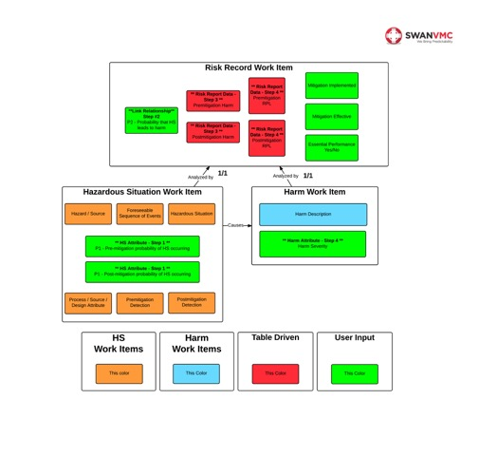**[**Open**]**

### Risk Management Tables

SabreProduction/D7371-5766**D7371-5766 -**The Calculation of RPL will comply with the following table process and be stored in the riskRecord work item.  
  
**P1 Factor**  
  
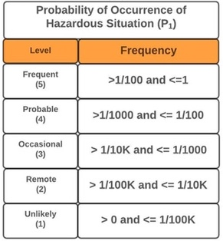  
  
**P2 Factor**  
  
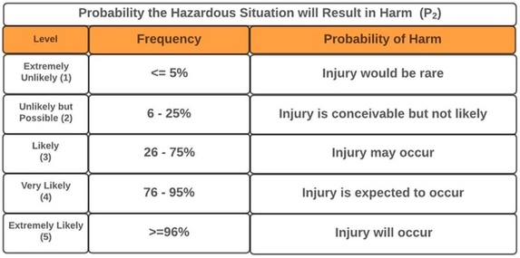  
  
**P Factor**  
  
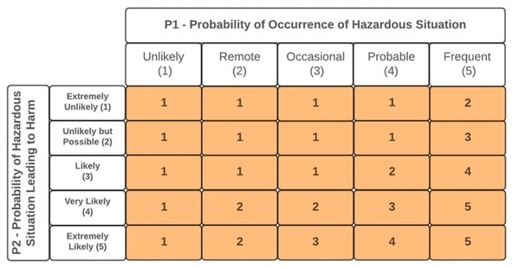  
  
**Severity**  
  
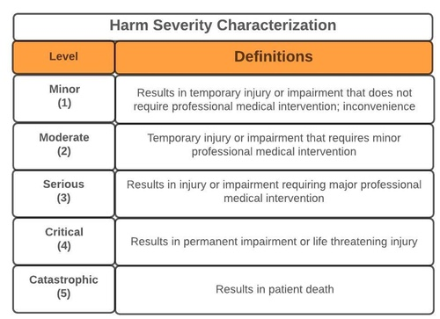  
  
  
  
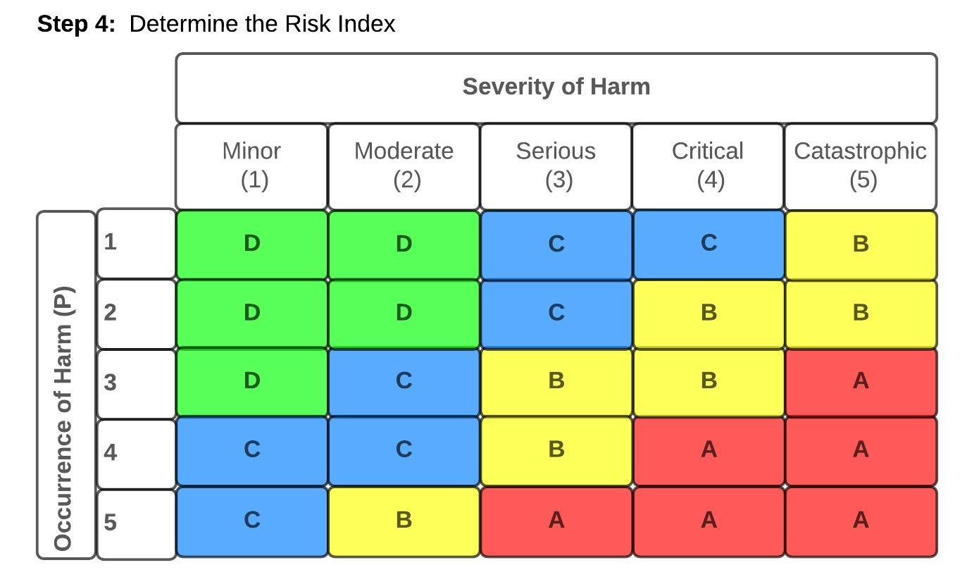  
  
**Risk Implication**  
  
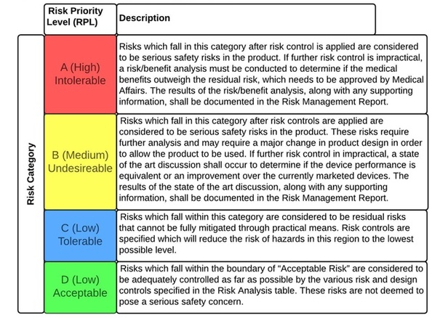  
  
  
**P Factor when it is not calculated, but selected**  
  
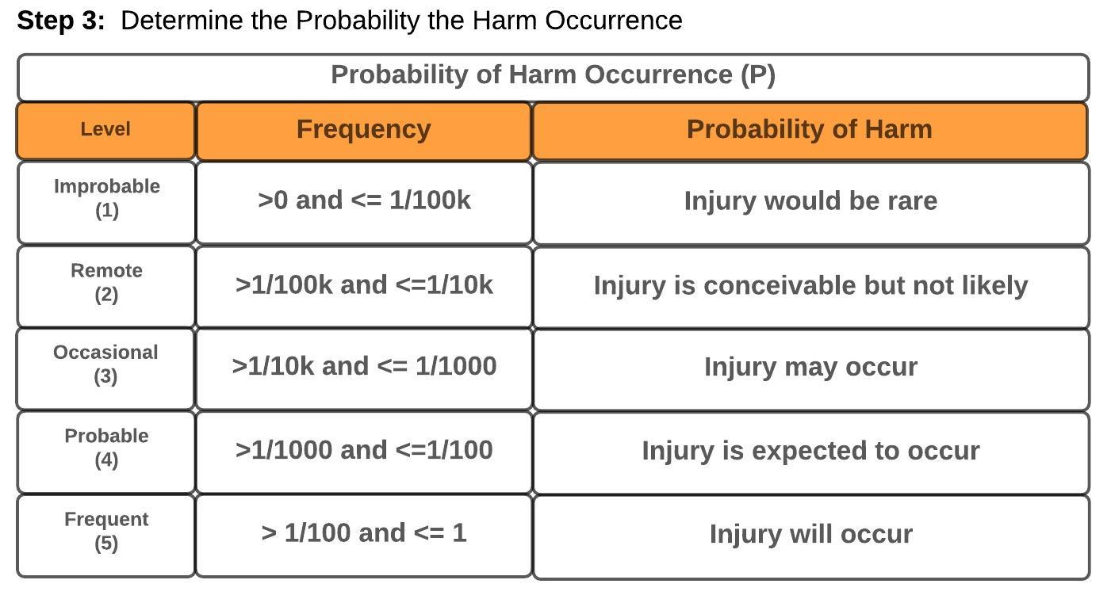  
  
​​**[**Open**]**

​​

​​

​​

​​